ASI ANYWHERE
ASI anywhere gives access anywhere, anytime via an internet connection to customers and outside employees.
It’s real time, so the minute that you ship inventory, your client can immediately review the information.
However, your company administers the security for what features and screens that your client can view or use.
Give your business and your sales people a competitive advantage

- Order Status
- Inventory Level Checks
- Account Balance
- Credit History with Aged Invoices
- Review and Reprint Signed Bill of Lading
- Review and Reprint Invoice Form in .PDF Format
- Release Deliveries with new dates, quantity and purchase order number.
- Request for Quotes via 3D Style Image
- Finished Goods Customer Inventory Reports
- Order Backlog Reporting
- Add New Orders
- Email Confirmations

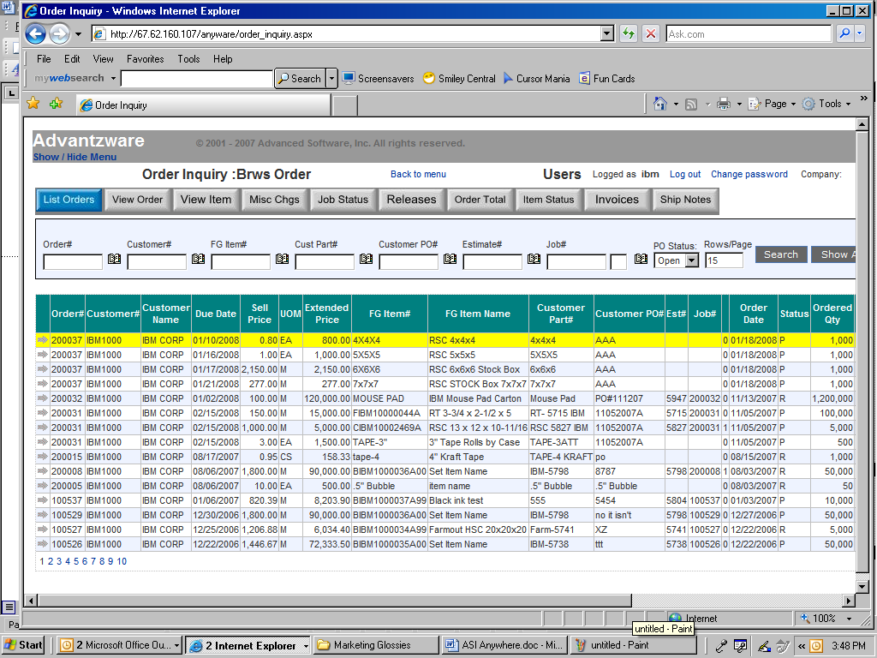

ASI ANYWHERE SECURITY

The first step to implement ASI anywhere is to defined users and their access rights.
External users are limited to what they see as what changes they can make. Whereas an internal user such an outside sales person or inside customer service analyst are only limited by security rights. Once defined, the login and password protects your critical corporation information. Underlying this security is the world renowned Microsoft SQL Server database combined with the web security of Progress software’s application server, which allows 25 to unlimited users simultaneous access to information in real time.

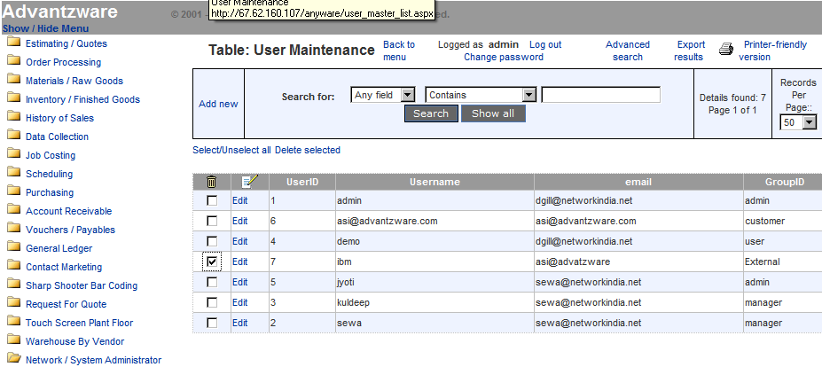

The Login ID and password limits external users to only their customer information.
The network security also limits what menu options are available by user.

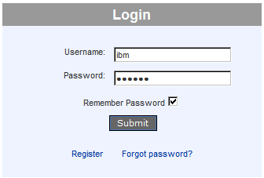

ASI ANYWHERE – LIST ORDERS

Orders may be found in a variety of ways. The more search criteria typed, the more refined the list of orders.
For example, you may enter a specific order number, purchase order number, part number, estimate or job.
Likewise, the user can limit the search to open, closed or all the customer’s purchase orders. The yellow bar indicates which item is selected. Once an item is selected, all the buttons or folders at the top of the order browser will focus on that item until the user selects another item.

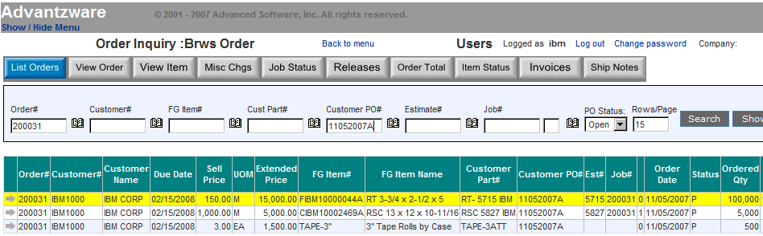

ASI ANYWHERE - VIEW ORDER

The View Order screen shows general information about the order such as the customer that will receive the invoice, the location that the products were sold to and pertinent data such as the sales person to contract.
Most information such as due date, purchase order number and shipping carrier may be changed for each item on the order or for each delivery release for the item.

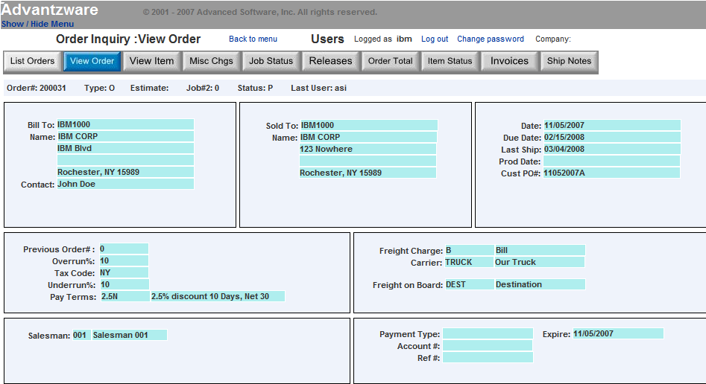
ASI ANYWHERE - VIEW ITEM

The View Item screen shows all the items for a specific order. The yellow bar indicates which item is selected. Once an item is selected, all the button or folders at the top of the order will focus on that item.
The buttons at the bottom of the item screen called ON HAND, ON ORDER and ALLOCATED, drill down to more detailed specifications. The on hand buttons shows a list of exact location

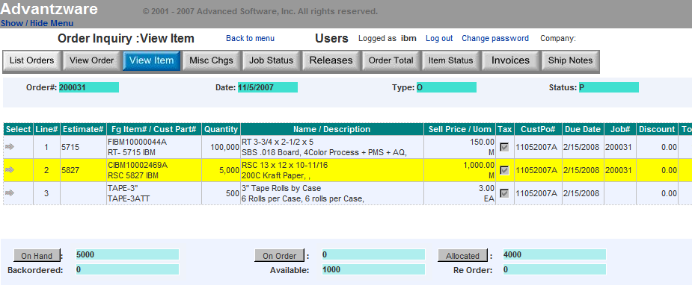

ASI ANYWHERE - VIEW ITEM

ON HAND button shows exact quantity on hand of inventory and location for the item selected. This shows the warehouse location, rack or bin location, pallet tag number and total quantity. This also shows if any specific pallet or specific location has been released or if the bill of lading has been processed, thereby alerting the quantity available for future deliveries.

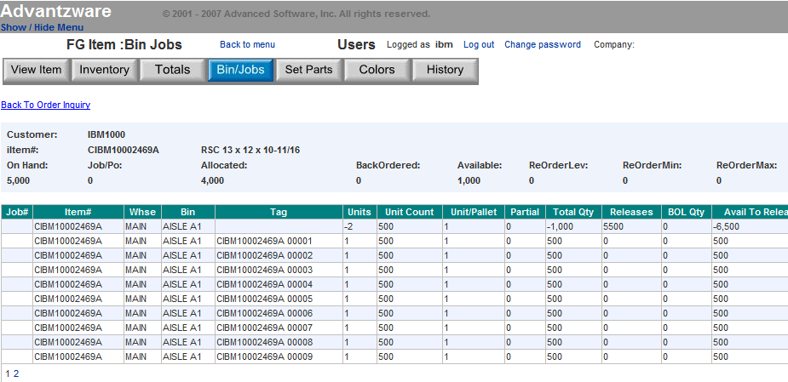

ASI ANYWHERE - VIEW ITEM

ON ORDER button shows exact quantity on order and the status of the job including state date as well as the jobs completed date. This also will show the customers order quantity, the productions job quantity including overrun, on hand completed, quantity shipped and amount remaining in work in process.

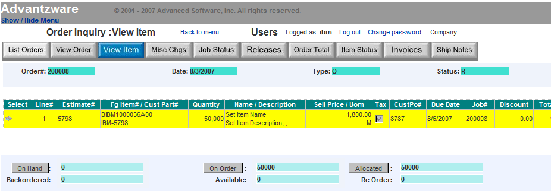

CLICK THE ON ORDER Button to Drill Down to Job Status.

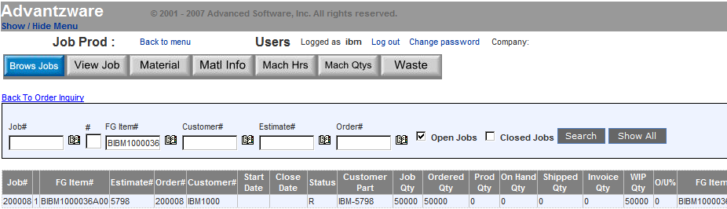

ASI ANYWHERE - VIEW ITEM

ALLOCATED button shows the details of the total order backlog of quantity committed for this item. The item may be on hand, but the quantity of open orders may exceed the on hand quantity. This inquiry shows which orders have been placed for this item with the appropriate due date, order date and delivery status.

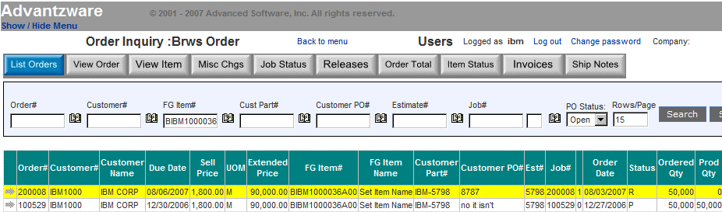

ASI ANYWHERE – MISC CHARGES

The MISC Charges details all the miscellaneous charges for the order along with the billing status.
Plate charges, die charges, warehousing and other one time changes related to a specific item on the order is listed for review. In addition, the total estimated weight, freight, tax and order total is listed.

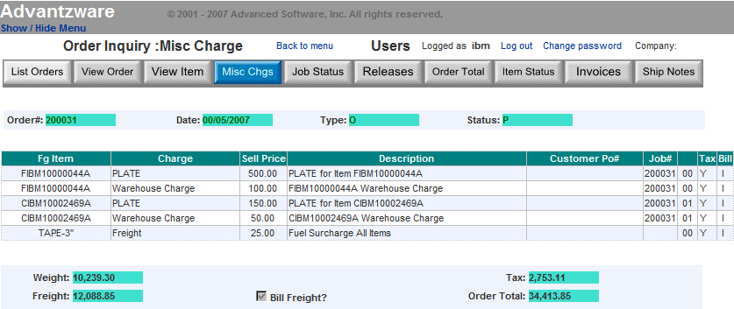

ASI ANYWHERE – SHIP NOTES

Specific shipping notes such as directions and doc times may be defined for each delivery release.

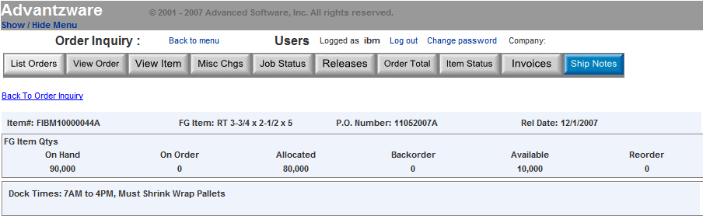

ASI ANYWHERE – ORDER TOTAL

Specific shipping notes such as directions and doc times may be defined for each delivery release.

